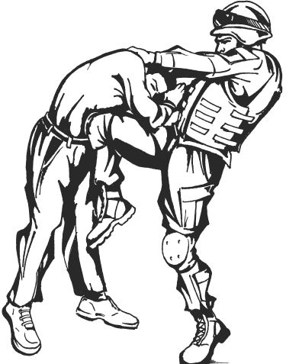
Feedback Worksheet
The United States Army Combatives Program relies on feedback from the force in order to produce the highest quality training to Soldiers worldwide. Please use this worksheet to provide feedback on anything that you feel could improve the US Army Combatives Program.
Send the finished feedback sheet to the USACC NCOIC, whose contact information can be found on the Fort Benning Combatives website below:
https://www.benning.army.mil/Armor/316thCav/129/Combatives/Contacts.html

Facility (Please include location and Post):
_______________________________________________________________________________________________________________________________________________________________________________________________________________________________________________________________

Administration (Please include Unit and Post):
_______________________________________________________________________________________________________________________________________________________________________________________________________________________________________________________________

Equipment (Please include location and Post):
_______________________________________________________________________________________________________________________________________________________________________________________________________________________________________________________________

Course Curriculum (BCC, TCC, CMTC): _______________________________________________________________________________________________________________________________________________________________________________________________________________________________________________________________

Professionalism (Please include Rank, Name, Unit, and Post):
__________________________________________________________________________________________________________________________________________________________________________________________________________________________________________

Timeline (BCC/TCC):
_______________________________________________________________________________________________________________________________________________________________________________________________________________________________________________________________
Program of Instruction / Lesson Plans:
_______________________________________________________________________________________________________________________________________________________________________________________________________________________________________________________________

Tournament:
_______________________________________________________________________________________________________________________________________________________________________________________________________________________________________________________________

Sustains to the Program:
_______________________________________________________________________________________________________________________________________________________________________________________________________________________________________________________________

Improvements to the Program:
_______________________________________________________________________________________________________________________________________________________________________________________________________________________________________________________________
Additional Comments/Suggestions:

